Presentation Title (Calibri,14 punto)

Name and Surname of First Author (Calibri, Bold, 11 punto)

Company name- Department, Post code, City, Country, e-mail address (Calibri, Italic,11 punto)
ORCID: xxxx-xxxx-xxxx-xxxx (All authors ORCID No. must be given for each authors, otherwise paper will be rejected)

Name and Surname of Second Author (Calibri, Bold, 11 punto)

Company name- Department, Post code, City, Country, e-mail address (Calibri, Italic,11 punto)
ORCID: xxxx-xxxx-xxxx-xxxx (All authors ORCID No. must be given for each authors, otherwise paper will be rejected)

Cite this paper as: Surname, FN, Surname, FN. Article title.Int. Conf. Advanced. Mater. Sci.& Eng. HiTech.and Device Appl.Oct. 24-26 2024, Ankara, Turkiye (Write here your present paper/abstract information, otherwise paper will be rejected )

Abstract. (Calibri, 10 punto) The presentation text starts here and continues. The abstract should be prepared via Calibri (Font) and 10 pts, single spaced with 2 cm margins on all sides and align full. The length of Abstract should be between 150 and 200 words. The abstract should be informative by referring study aims, the methodology, the instruments, the major findings and the implications of the study.

Keywords: (Calibri, 10 punto, 3-up to 5 should be given)
© 2024 Published by ICMATSE

Short introduction and methods of the study should be given here (Calibri, 11 punto). The figure names should be given below the Figure and the name “figure” should be italicized (Fig. 1). Reference to equations sould be given as Eq. [1] or multiple references as Eqs. [1-4] or Eqs. [1,2]. Reference to general text sould be given as [1] or or multiple references as [1-4] or [1,2].

Table 1. Table caption (Calibri, Italic,10 punto)
Random | text | Random text
continue | Random text | Random text
Text | Random text | continue
Text | Random text | continue

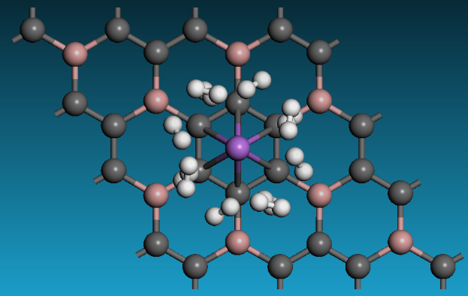
Figure 1. Figure caption (Calibri, Italic,10 punto)

Important results should be given shortly. The table names should be placed above the table. There should be the word “Table” and the brief explanation of title should be found and italicized (Table 1). Total abstract should be maximum one page [2].

This template will also be used when preparing the full text. Unlike the extended abstract, the full text will consist of a maximum of 4 pages and will be organized as Abstract, Introduction, Results and Discussion, Conclusion and References.
References (Calibri,10 punto)
1. M. Niinomi, Mechanical biocompatibilities of titanium alloys for biomedical applications, J Mech Behav Biomed Mater, 1 (2008), pp. 30-42, 10.1016/j.jmbbm.2007.07.001
2. Ahmet Bayirli, Semra Ide, Ilghar Orujalipour, Osman Demir, Murat Dursun, Hakan Ates, Nanoscale structural investigation on Ti-6Al-4V implants produced by using selective laser melting technique: The importance of production angle, J Mater Res Techno 8 (2019), pp 2796-2801, doi.org/10.1016/j.jmrt.2019.04.019
3. Yorulmaz, Beyza Yesilbag; Ates, Hakan; Er, Zuhal; Climatic chameleon house design and solar calculations, 4th Int. Conf. on Eng. Technol and Applied Sci. (ICETAS) 2019 Kiev, Ukraine

